Duty Scheduler Guide

# Installation:

### Transfer to OSN:

Download the file at <https://github.com/jeijii/sbnfilter>. Under Code, Download ZIP.

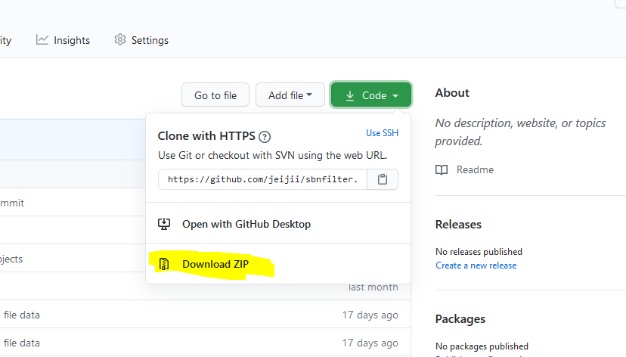

Extract the file, then transfer the index.html file to OSN if needed. All other files are not needed.

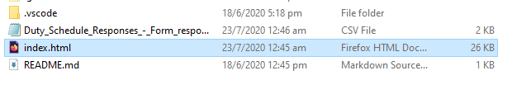

Double click on the index.html file to run.

### Computer with Internet Access:

If there is internet access,

<https://jeijii.github.io/SBNDutyScheduler/index.html> is the link to the duty scheduler

# Usage:

## Step 1: Creating Google Forms to collect Submissions

Create a google forms with the exact format to make sure the program can read it. If the forms is not done properly, the website will not load.

### First Input: Name

First, create a dropdown menu with all the names of everyone that will be doing duty.

**TAKE NOTE** for the ones that are staying out, please add a space, followed by “(Stay Out)” beside the name. This is used by the program to only assign that person weekend duties. Not doing so, or following wrongly will result in being assigned a weekday duty.

Example:

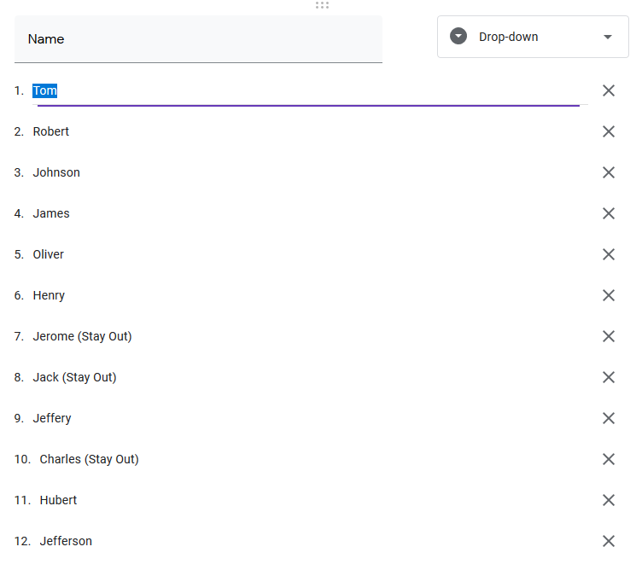

### Next 5 inputs, Preferences

We will give 5 dates for them to choose. To prevent them from giving invalid values like, “only Wednesday please” or “no weekdays please”, we will only allow them to select dates.

Example:

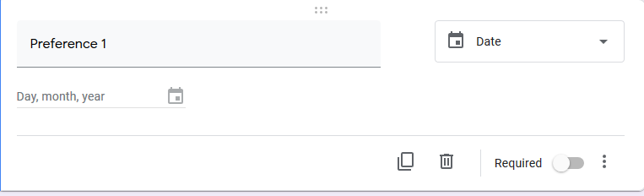

Total Example:

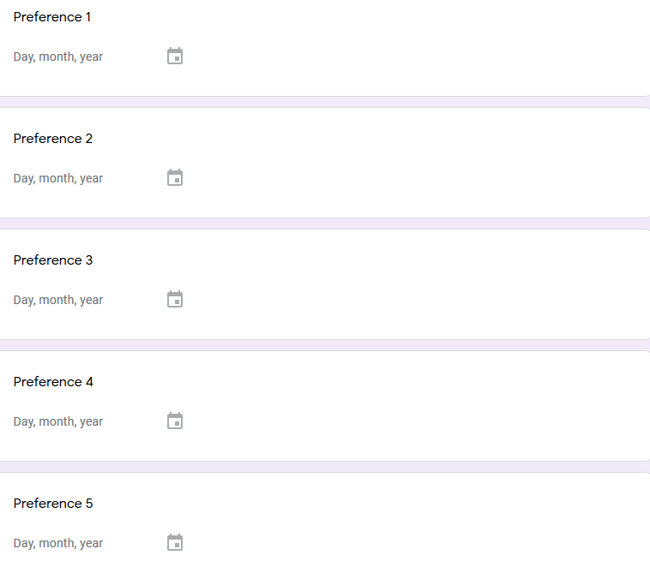

### Next 5 inputs, Exclusions:

We will give 5 dates for them to exclude. Do the same as Preferences.

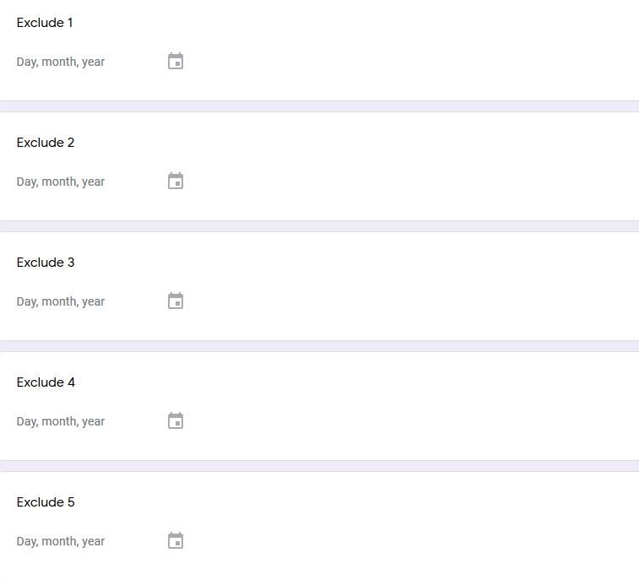

### Link to example:

<https://forms.gle/6VgRzLG8VjHFMSfM7>

## Step 2: Prepare the responses for the program

Once all responses are collected, make sure that there are no repeats. Also, some people might not have filled it in, so we have to add their name in as well.

First, Open the file in sheets.

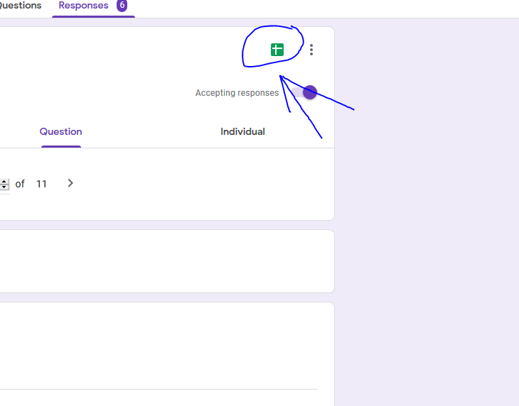

As we can see in the picture below, Tom has submitted twice, and left everything blank. That is okay, if they leave it blank, we will randomly assign them duty. We use the timestamp to delete the oldest entry and leave the newest entry in.

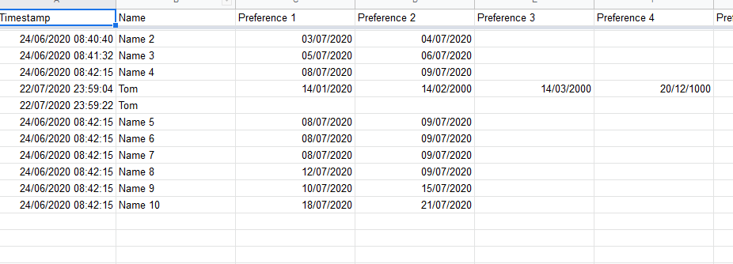

The only one entry of Tom is left.

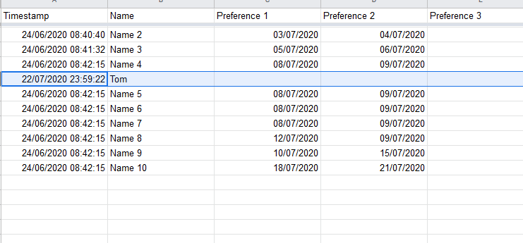

If anyone forgets to submit, add their name in. In the picture below, we added a new name in the Name column. Leave everything else blank.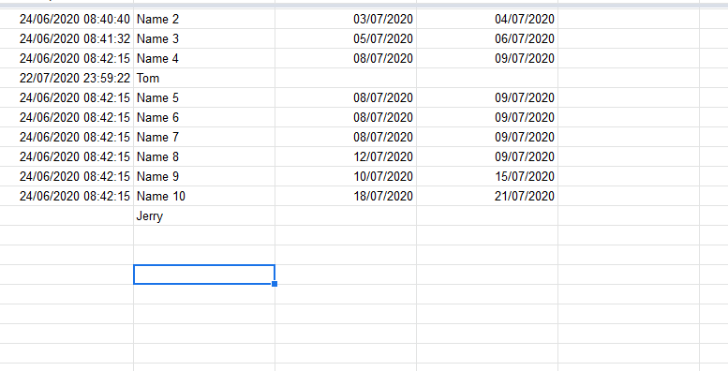

## 

## Step 3: download the csv file.

Under File > Download > Comma-separated values

## 

The file then can be transferred to OSN if needed.

## 

## Step 4: Drag and Drop the file to the website

Launch the index.html. Click on Allow Blocked Content if on Internet Explorer.

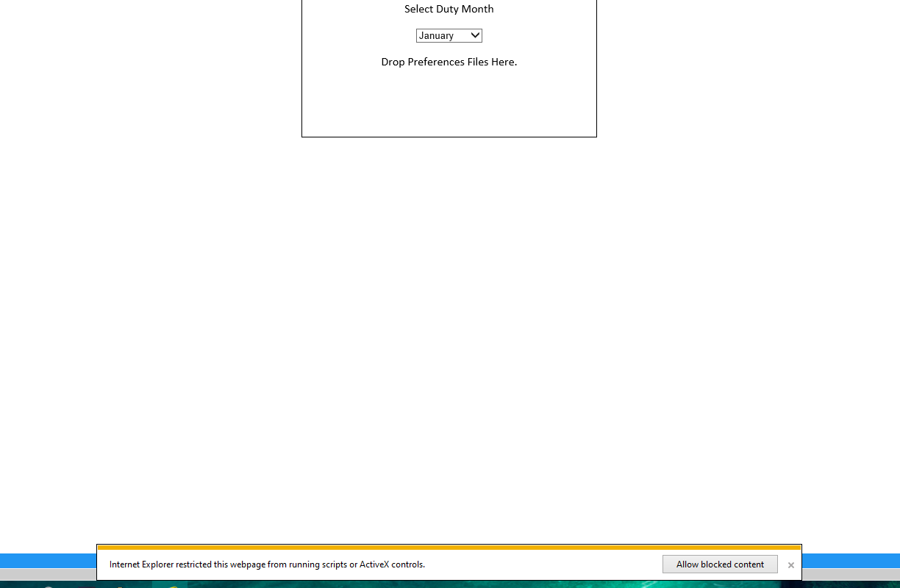

### Choose Date:

Choose the month of duty.

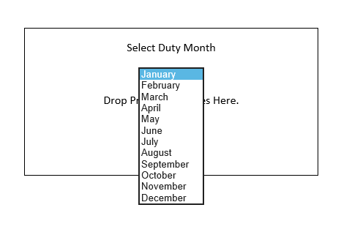

### Drag the CSV to the Box:

Next, drag the CSV file downloaded into the box.

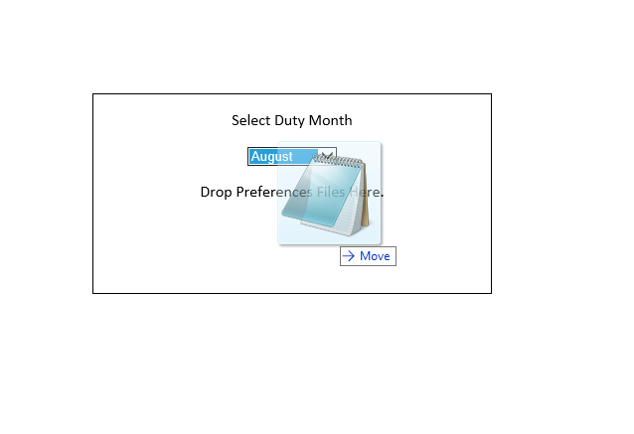The next page should appear.

### Fill in the number of duties per person that month:

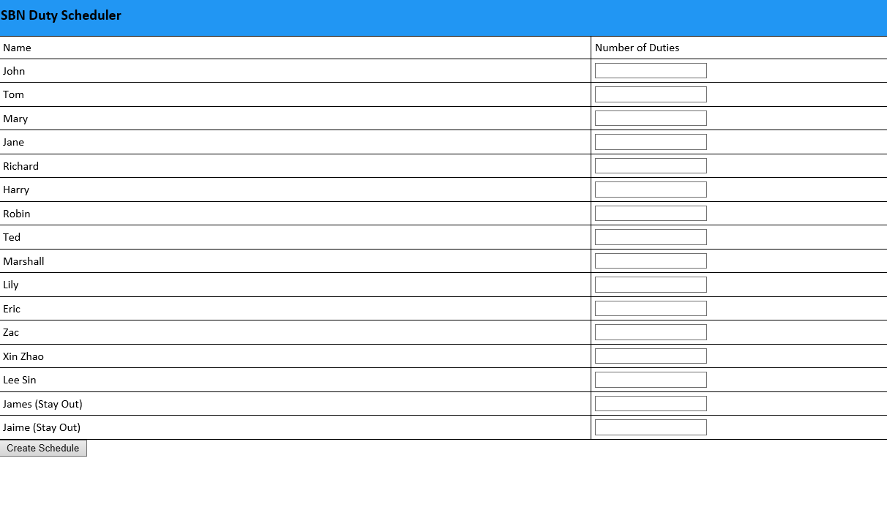

As you fill in the number of duties per person, The top will show you the total amount of duties there are, as well as the current amount of duties filled in. **NOTE** Please only fill in numbers, and do not leave spacing. Also, Fill in the duties for each person until the Total Duty Count Matches with the Total Duties Needed.

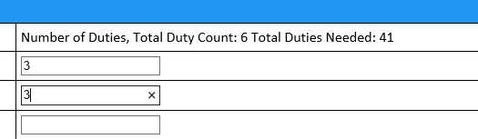

Example of completed form:

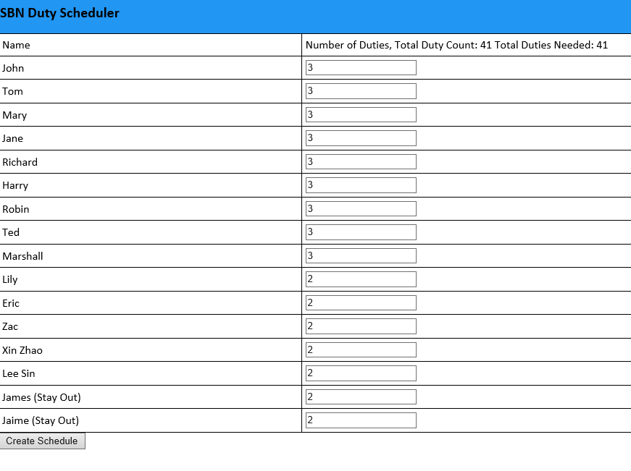

Once that is done, click on Create Schedule.

### Create Schedule:

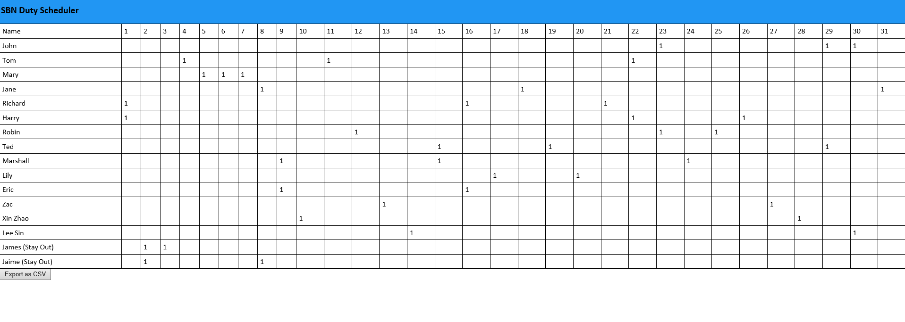

Once the Create Schedule button is pressed, The program will use the Hungarian Algorithm to produce the schedule. This removes any biases.

### Add Reserve:

Pressing on an empty cell will add a “R” indicating reserve.

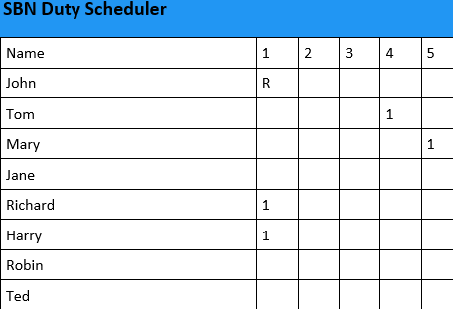

Press Again to remove the “R”. You can choose to export the file and add the reserves in later too.

### Save the file:

Press the export as CSV file to download the file, to be opened in excel.

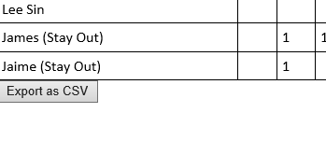

Click save to download the file.



The file can now be opened on excel for editing.

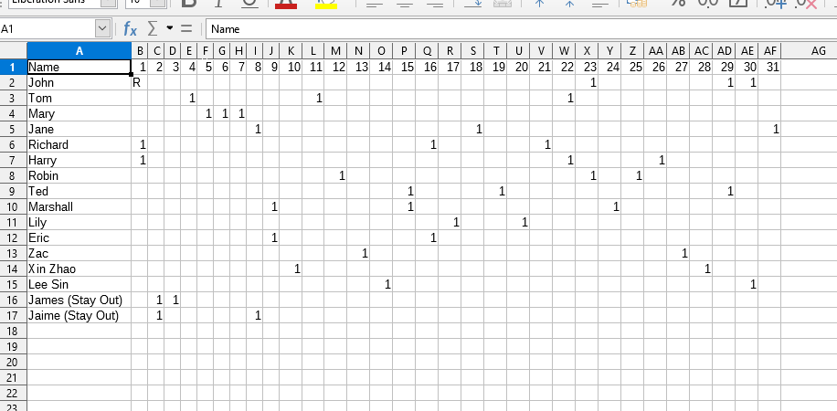

# Additional Information:

### If there are any issues, try reloading the page and try again.

Any problems with the program or questions involving the use of the program please text or call LCP Tan Jing Zhi at 81817928.